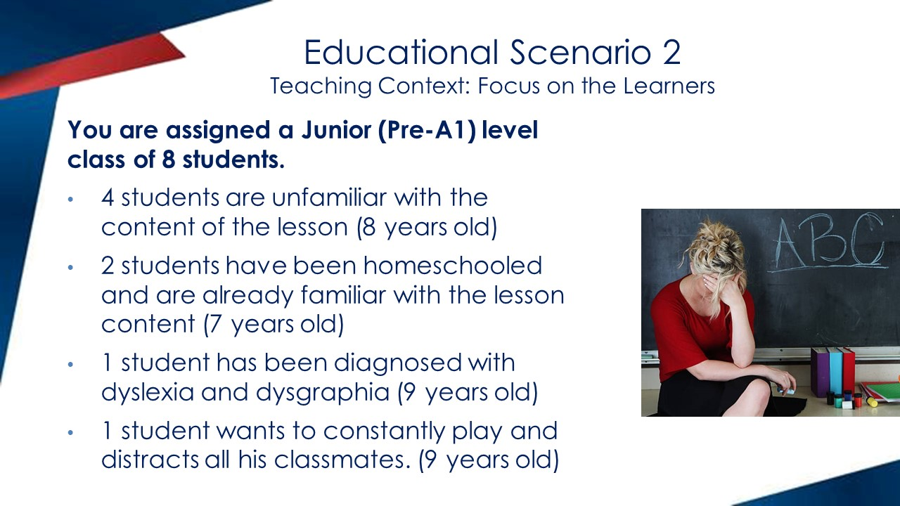

Have… got…? / Has… got…?
An illustrated three panel story follows showing two kids talking/texting on their mobile phones. The publisher has produced a video to be shown on board, based on the story.
1st panel:
Boy asking: Has your town got a mall?
Girl answering: No, it hasn’t.
2nd panel:
Boy asking: Has it got a cinema?
Girl answering: Yes, it has.
3rd panel:
Boy asking: Have you got a picture of your town to send me?
Girl answering: Yes, I have.
Theory Box:
In English (if it is a book for Greece, it can also be in Greek) we use Have… got…? / Has… got…? to ask about possessions and places. We put Have/Has at the beginning of the sentence. We answer with Yes, I/we/you/they have- he/she/it has. and No, I/you/we/they haven’t- he/she/it hasn’t.

Exercise 1: Write Have / Has and answer the questions.
Author’s Note: Engaging Activity
1. Have you got a pet? Yes, I have.
2. _____ he got a bike? __________.
3. _____ the town got a café? __________.
4. _____ they got notebooks? __________.
5. _____ Mary got an umbrella? __________.

Exercise 2: Look and write questions and answers.
Author’s Note: Illustrated Activities to further clarify meaning
(we have a picture of a map of a town with buildings and streets. We see on the map a park, a hospital, a cinema, a restaurant and a train station)
1. Has the town got a cinema? Yes, it has.
2. Has the town got an airport? No, it hasn’t.
3. ______________ a bank? No, it hasn’t.
4. Has the town got a park? __________.
5. ______________ a train station? Yes, it has.
6. Has the town got a funfair? __________.

Exercise 3: Circle.
Author’s Note: Illustrated Activities to further clarify meaning
(next to each question there is a picture for students to look and find the answer)
1. Have I got a green hat? (a girl with a green hat on her head)
Yes, you have / No you haven’t.
2. Has the teacher got our notebooks? (a teacher sitting at her desk /no notebooks on it)
Yes, she has. / No, she hasn’t.
3. Have Jack and Ben got tickets for the cinema? (two boys holding tickets)
Yes, they have. / No, they haven’t.
4. Has Steven got a skateboard? (a boy with his skateboard at the park)
Yes, he has. / No, he hasn’t.
5. Have the girls got pet dogs? (two girls holding their cats)
Yes, they have. / No, they haven’t.
6. Has Lily got a sandwich and lemonade? (a girl sitting at a café having a milkshake)
Yes, she has. / No, she hasn’t.

Exercise 4: Write questions and answers.
Author’s Note: Graded exercise to assist students in the process of recognition to production and embedment of lesson.

1. Tim / a scooter 4. Tina and Leo / their school bags
Has Tim got a scooter? ____________________
Yes, he has. ______________.
2. the boys / a ball 5. Eric / a jacket
____________________ ____________________
_____________. ______________.
3. your town / a swimming pool 6. Helen/ a pet rabbit
____________________ ____________________
______________. _______________.

Exercise 5: Read and tick ().
Author’s Note: Fun exercise that focuses on meaning
(next to the text there is are two pictures. Picture 1 shows a picture of a street with houses, a pet shop, a bus stop and a café. Picture 2 shows a picture of a street with houses, a bank, a bus stop and a school. Each picture has a white box so students can tick the correct picture.)
Text: This is a picture of my street. It has got a few houses and a lot of trees. Every morning I take the bus to go to school. The bus stop is in front of the pet shop. My street has got a café where we meet with my friends after school. I walk a few metres to go home after the café. My house has got a red roof. It hasn’t got a garden, but it has got a garage path. Have you got a café in your street?

Exercise 6: Answers about me!
Author’s Note: Personalized Writing Activity

1. Have you got a pet? 4. Has your teacher got short hair?
_____________________________ _____________________________
2. Has you Dad got a car? 5. Have you got blue eyes?
_____________________________ _____________________________
3. Has your town got a park? 6. Have you got a lot of friends?
____________________________ _____________________________

END OF LESSON

Copyright © 2023 by Katherine Reilly
All rights reserved. None of these materials may be reproduced or used in any manner without written permission of the copyright owner except for the use of quotations in a presentation or book review.

email: katherinereilly1@yahoo.com

